Timothy McDermott (Student ID: 100351319)

Website URL: <https://sites.google.com/view/timothy-mcdermott-eclipso/home>

Email: [timothymcdermott@email.kpu.ca](mailto:timothymcdermott@email.kpu.ca)

Github: [https://github.com/Tohserus/INFO-Assignment-3](https://www.google.com/url?q=https%3A%2F%2Fgithub.com%2FTohserus%2FINFO-Assignment-3&sa=D&sntz=1&usg=AFQjCNHSaLOVxySFsfmAOogD_YkvOsExxQ)

Liam Harder (Student ID: 100376013)

Website URL: <https://sites.google.com/view/info-1113-website/home>

Email: [liam.harder@email.kpu.ca](mailto:liam.harder@email.kpu.ca)

GitHub:[https://github.com/liamharder/Eclipso](https://www.google.com/url?q=https%3A%2F%2Fgithub.com%2Fliamharder%2FEclipso&sa=D&sntz=1&usg=AFQjCNE_7Na9AxxX_NgXO1NdLqn7mc9ivg)

Aaron Gill (Student ID: 100359038)

Website URL:<https://sites.google.com/view/info-1113-project>

Email: [aaron.gill2@email.kpu.ca](mailto:aaron.gill2@email.kpu.ca)

Github:[https://github.com/aarongill99/INFO-1113-Assignment3](https://www.google.com/url?q=https%3A%2F%2Fgithub.com%2Faarongill99%2FINFO-1113-Assignment3&sa=D&sntz=1&usg=AFQjCNFQrjvCF4tViVi_RdQTBhj7I0nLvA)

[Company name] | [Company address]

**Eclipso Final Project**

INFO 1113 Systems Analysis and Design Section: S11 Project Title: Eclipso Date: November 26, 2019

Table of Contents

Executive Summary 2

Introduction 2

Project Requirements 2

Use Case Diagram 3

Use Case Descriptions 4

Display Eclipses 4

Display Accommodation 5

Find User Location 6

Class Diagram 7

Sequence Diagram 8

Interface Prototypes 9

Entity Relationship Diagram 10

Database 10

Project Experience 11

Liam Harder 11

Aaron Gill 11

Timothy McDermott 11

Conclusion 11

Works Cited 12

# Executive Summary

Hello and welcome to the Eclipso App report! In this we shall dive into the wide array of features that the app has to offer! From accommodation to eclipse trails there is plenty Eclipso has to show. At the beginning we delve into a bevy of info listing the general purpose of Eclipso, that being a personalized eclipse tracker, accommodation finder and somewhat of an eclipse informative for the casual public, or dedicated eclipse hunters.

# Introduction

Eclipso is an Eclipse tracker application used to see upcoming eclipses overlaid over a globe and can be used to book accommodations closest to you in the trajectory of the most optimal viewing angle. In this report we will provide a through description of the functional and non-functional requirement's, a fully developed use-case diagram of the system, a class diagram with associations and multiplicity, a sequence diagram, prototypes of the interface, and a E-R diagram as well as a access database.

# Project Requirements

Functional Requirements:

Display local and global maps of upcoming eclipses

Display local accommodations

Display eclipse safety information

Non-Functional Requirements:

Multiple ways to input location

Adjustable range of interest

Ability to filter different types of eclipses/celestial events

# Use Case Diagram

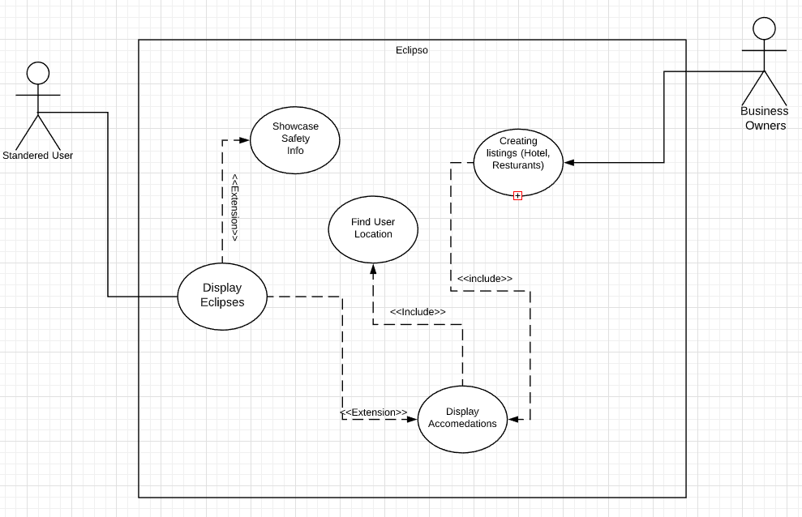

# Use Case Descriptions

Display Eclipses

Primary Actor: User

Level: Kite Level

Stakeholders: User, business owners

Preconditions: There must be eclipses in the database ready to be displayed.

Minimal Guarantee: It will show the user a map of the world.

Success Guarantee: User will be displayed a large map where they can see all future eclipses and can scroll around the globe to see more.

Trigger: User opens the Eclipso application.

Main Success Scenario:

1. User opens the Eclipso application.

2. The application accesses the eclipse database, either stored within the application locally or data retrieved from online.

3. The application finds the eclipse and shows all the eclipses happening that year plotted on a map.

Extensions:

1.a.1. User opens the Eclipso application.

1.a.2.The application accesses the eclipse database, either stored within the application locally or data retrieved from online.

1.a.3.The application finds the eclipse and shows all the eclipses happening that year plotted on a map. The 6user chooses to click on one of the buttons:

o Showcase Safety Info

§ Shows safety precautions and measures you can take to protect yourself.

o Display Accommodations

§ (See below Display Accommodations Use Case)

Exceptions:

1. No Database detected

(1) An error pops up on screen telling you:

(a) If the database is local to reinstall the application.

(b) If the database is retrieved from the internet, to try reconnecting.

(2) Shows the map without plotted eclipse locations.

2. If no eclipses are happening within the specified timeframe.

(1) Gives user option to choose date range.

**Created by: Aaron Gill Reviewed by: Timothy McDermott**

Display Accommodation

Primary Actor: User

Level: Kite Level

Stakeholders: User, business owners

Precondition: User must have access to the internet to find updated and accurate listings, as well as enter in their current position for accurate listings.

Minimal Guarantee: App will show a list of restaurants, hotels, hot spots within the users selected range of interest, (As well as their GPS position).

Success Guarantee: App showcases accommodation to the user, their ratings, position in the eclipse and accessibility

Trigger: Use case begins when the user selects the “Accommodations” button from the display eclipses, which will bring them to an accommodation listing page.

Main Success Scenario:

1. App uses GPS or user entered location, as well as their entered range of interest.
2. App uses internet to update accommodation listings, new reviews, scores and locations
3. App displays to user all of the obtained into, and allows them to search the sites name.

Extensions:

1.a. App cannot find an internet connection to update listings

1.a.1. App displays that it must have an internet connection to find accommodation

1.a.2. App displays button to return to the main menu

2: GPS finds a wrong location, or a glitch happens with the user entered location

2.a.1. user may go to settings and select to recalibrate their location

2.a.2. App attempts to locate user using GPS

2.a.3. If the app cannot find the users location, ask user to enter their location (country, state/provinces/town)

**Created by: Timothy McDermott Reviewed by: Aaron Gill**

Find User Location

Primary Actor: User

Level: Kite level

Stakeholders: User

Precondition: User must be using a device that allows for GPS location and has a working Internet connection

Minimal Guarantee: App will display global map of events and accommodations

Success Guarantee: User’s location will be recorded and used to determine local accommodations and events

Trigger: User attempts to find accommodations or events near their current location

Main Success Scenario:

1. App connects to location-finding service

2. App sends GPS coordinates to service and receives location

3. App calculates distance to local points of interest from current location

Extensions:

1.a. Device cannot connect to location-finding service

1.a.1. App displays error message for user and attempts to reconnect.

1.a.2. App prompts user to enter location manually via street address or coordinates

1.a.3. App is unable to determine location and simply displays global map

2.a. Service returns incorrect location

2.a.1. App prompts user to confirm correct location

2.a.2 App prompts user to enter location manually

**Created by: Liam Harder Reviewed by: Timothy McDermott**

# Class Diagram

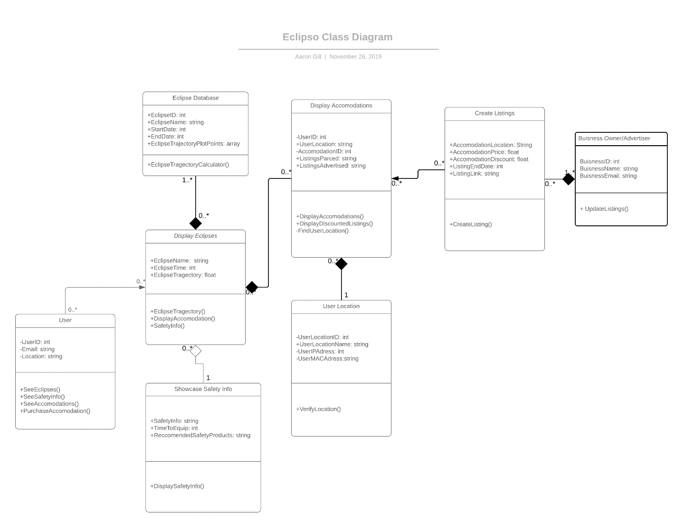

**Created by: Aaron Gill Reviewed by: Liam Harder**

# Sequence Diagram

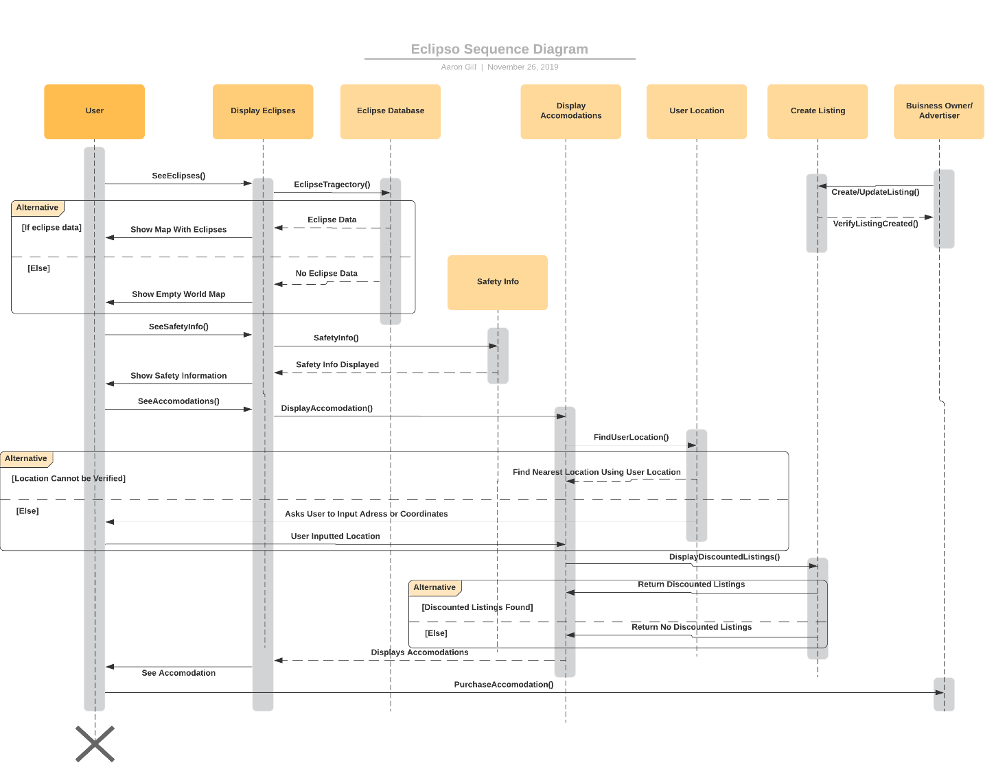

**Created by: Aaron Gill Reviewed by: Liam Harder**

# Interface Prototypes

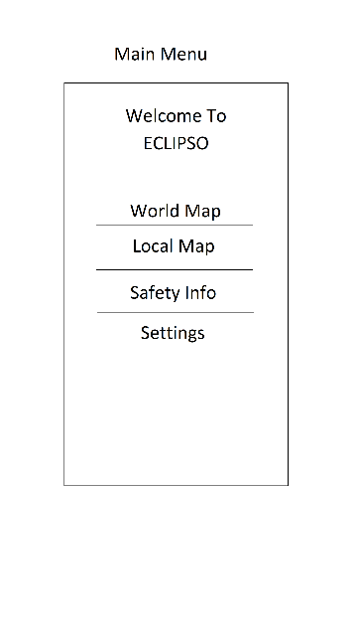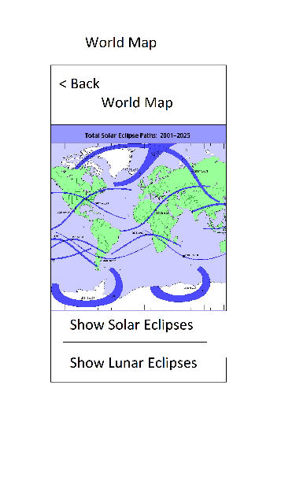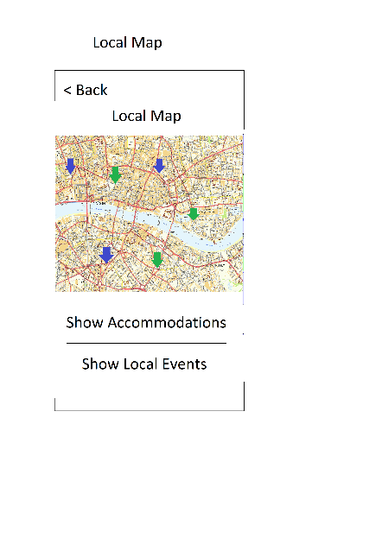

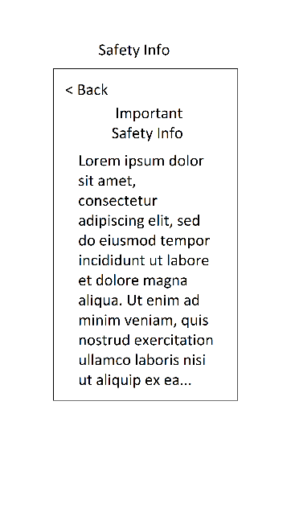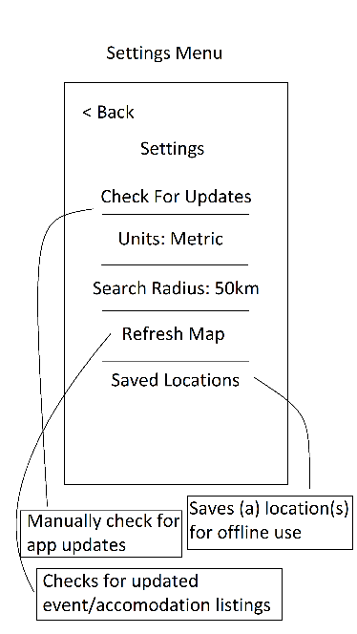

**Created by: Liam Harder Reviewed by: Timothy McDermott**

# Entity Relationship Diagram

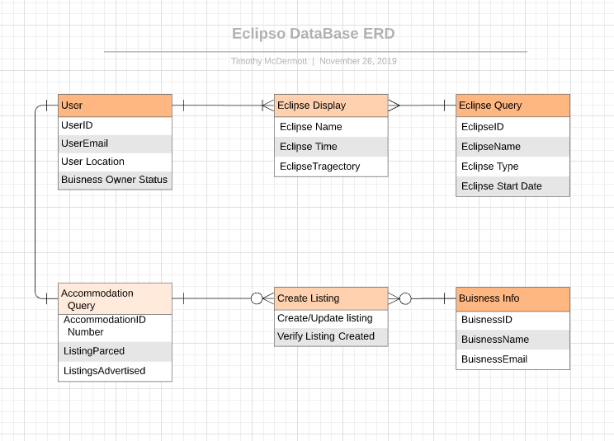

**Created by: Timothy McDermott Reviewed by: Aaron Gill**

# Database

Attached as zip file to the submitted document

**Created by: Timothy McDermott Reviewed by: Aaron Gill**

# Project Experience

Liam Harder: I think the project went smoothly. The few communication errors that occurred were resolved efficiently. The biggest obstacle we faced in my opinion was ambiguity in what we were supposed to do, but we overcame that issue through communication and organization.

Aaron Gill: This project was a very good learning experience, it challenged key communication and understanding skills. Most of our communication was over text, and sometimes can be confused or mis-interpreted. Overall, I believe that the organization skills that were required to complete this project challenged me in a way that I haven't been challenged and that I can take with me in future endeavors.

Timothy McDermott: This assignment was the biggest one I've had in a while and offered a few road bumps along the way, those mainly being communication and understanding what was requested from myself and the team. My sections of the project were easy enough to handle, as I feel my team mates also felt this. Made similar by the team supporting each other every step of the way. My main take away has been the communication of my team, and how much it benefits everyone when people talk.

# Conclusion

In summary, the Eclipso team has been able to design all the necessary components for the project. The team was well coordinated and was able to communicate effectively to overcome problems as they arose. The designs for the databases, interfaces, use cases, and entity relationship diagrams are solid and robust. The whole team learned a lot from working on this project, from communications skills to the finer points of systems design.

# Works Cited